📘 Day 1 Preparation Notes

Day 1 Study Notes
- Frontend
- Cross-Platform Development
- React Native
- Expo
- React Native Web
- TypeScript

Tribaze Internship Preparation

- Frontend
Frontend is the visible part of an application that users interact with directly.

Example:
Instagram
Everything you can see:
- Feed
- Like button
- Stories
- Comments
- Search
is Frontend.
A frontend developer focuses on creating attractive, responsive, and user-friendly interfaces while ensuring seamless interaction with backend services through APIs.

📷 Frontend vs Backend architecture diagram
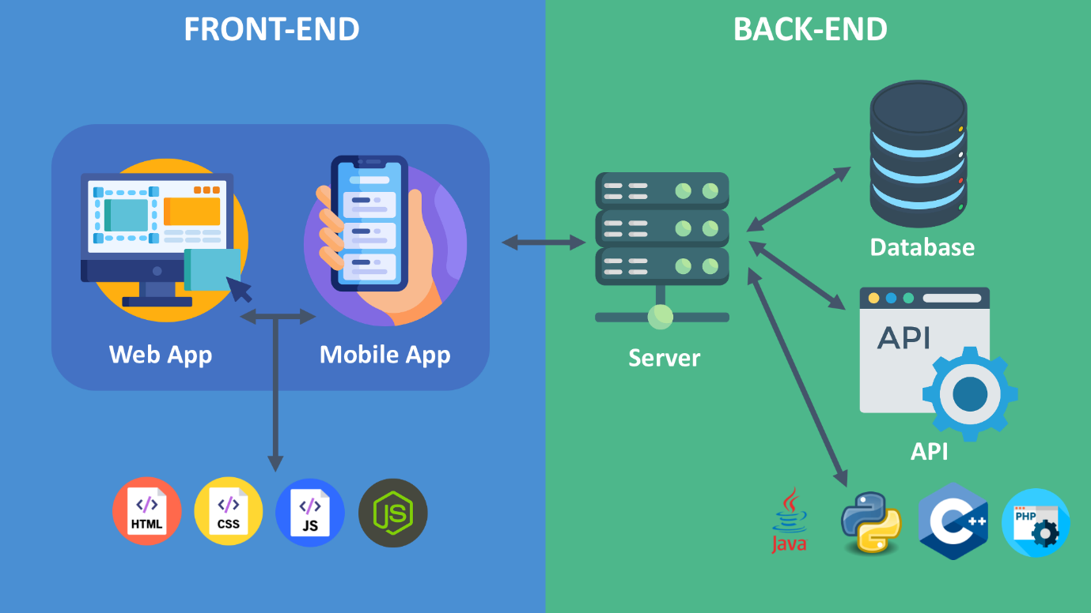
1.2 Frontend Technologies
Technology | Purpose
HTML | Structure
CSS | Styling, Designing
JavaScript | Functionality
React | Web UI
React Native | Mobile Apps
TypeScript | Type Safety

1.3 Frontend Workflow
User
↓
Clicks Button
↓
Frontend
↓
API Request
↓
Backend
↓
Database
↓
Response
↓
Frontend Updates UI

Real-Life Example
Food Delivery App

Customer clicks
Order Food
↓
Frontend sends request
↓
Backend processes order
↓
Database stores order
↓
Frontend shows
"Order Confirmed"

Business Use Case
Suppose we have Amazon app

Frontend displays (Frontend Part)
- Products
- Cart
- Reviews
- Search
Backend handles (Backend Part)
- Payments
- Inventory
- Authentication
2. Cross-Platform Development

Definition
Cross-platform development means writing a single codebase that runs on multiple operating systems like Android and iOS.
Instead of creating separate applications for Android and iPhone, developers write one application that works on both platforms.

📷 Cross Platform diagram


Cross Platform
One Codebase
↓
React Native
↓
Android
↓
iOS
↓
Web (Optional)

Real-Life Example
WhatsApp
Facebook
Instagram
Many screens are shared between Android and iOS.

Business Use Case
In Startup companies Instead of hiring Android Developer & iOS Developer
They hire
One React Native Developer
saving both time and money.

Advantages
✔ Faster Development
✔ Lower Cost
✔ Easier Maintenance
✔ Shared Code
✔ Faster Updates

Disadvantages
✔ Slightly Lower Performance
✔ Platform-specific Code Sometimes Needed

3. React Native

Definition
React Native is an open-source framework developed by Meta that allows developers to build native mobile applications using JavaScript and React.
Unlike traditional web development, React Native uses native UI components instead of HTML elements.

📷React Native architecture
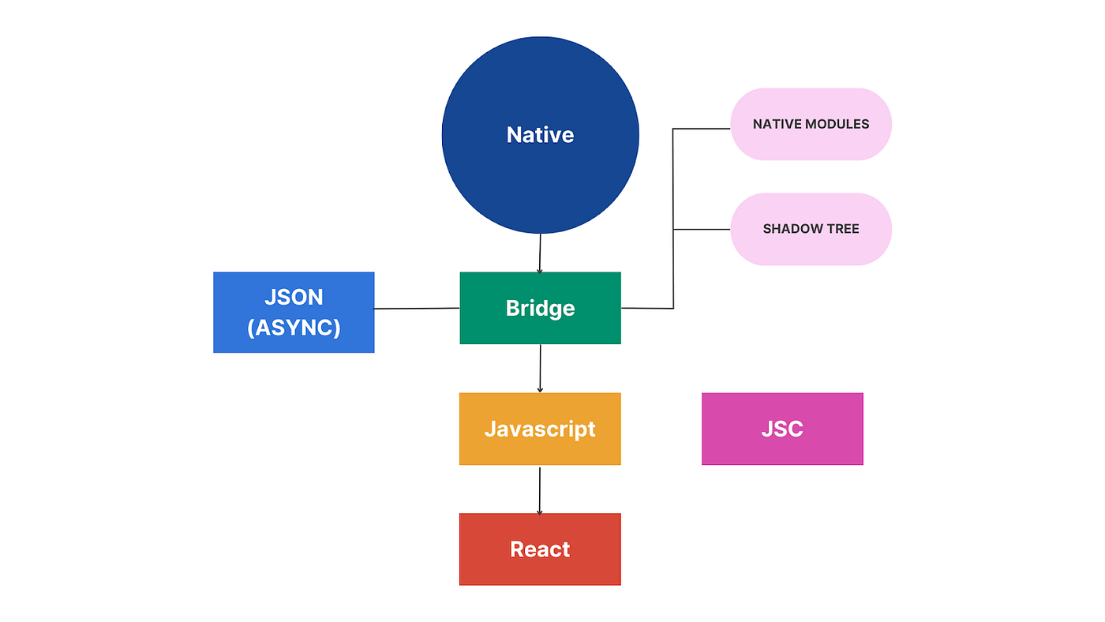

Architecture Diagram
JavaScript Code
↓
React Native Bridge
↓
Native Android/ Native iOS
📷React Native components
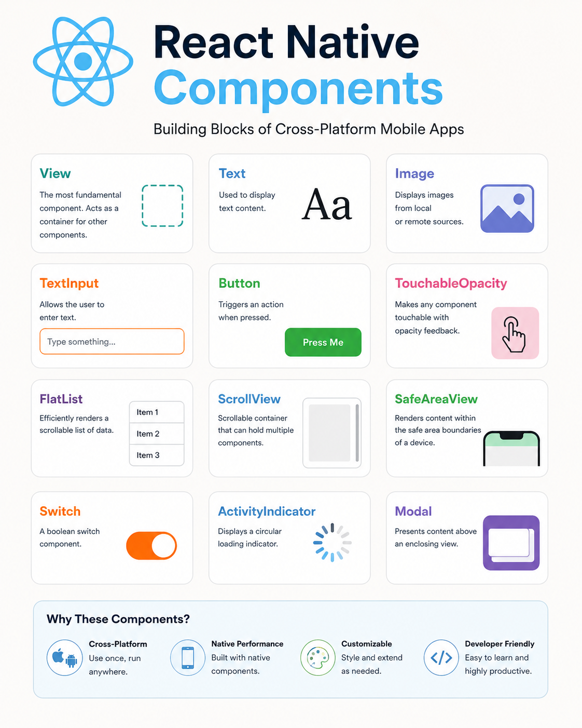

Folder Structure
App.js
components/
screens/
assets/
navigation/
services/

Real-Life Apps
Facebook
Instagram
Discord
Shopify
Tesla

Business Use Case
A company wants an app for
Android
iOS
React Native reduces
Development Time
Maintenance Cost
Testing Effort

4. Expo

Expo is a framework and platform built on top of React Native that simplifies mobile app development by providing ready-to-use tools, libraries, and services.
It eliminates the need for complex native setup, making it easier to build, test, and deploy applications.

📷 Expo architecture
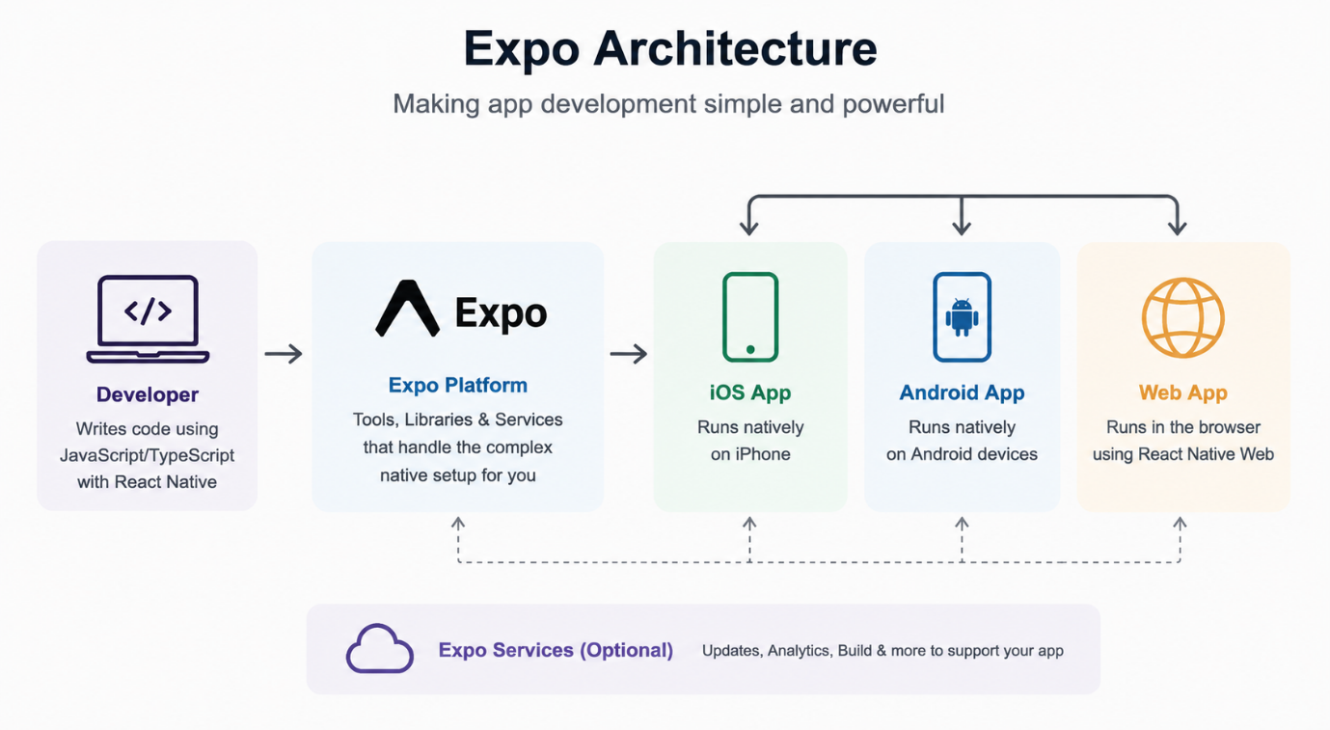

Real-Life Example
Developer writes code
↓
Scans QR
↓
App runs instantly

Workflow
Write Code
↓
Save
↓
Expo Go
↓
Mobile Updates Automatically

Features
Expo Go
Live Reload
Hot Reload
OTA Updates
Notifications
Camera API
Location API

Business Use Case
Startups use Expo because
No Android Studio setup
Fast development
Easy testing

5. React Native Web

React Native Web is a library that enables React Native components to run on web browsers, allowing developers to build web and mobile applications using the same codebase.
📷 React Native Web architecture
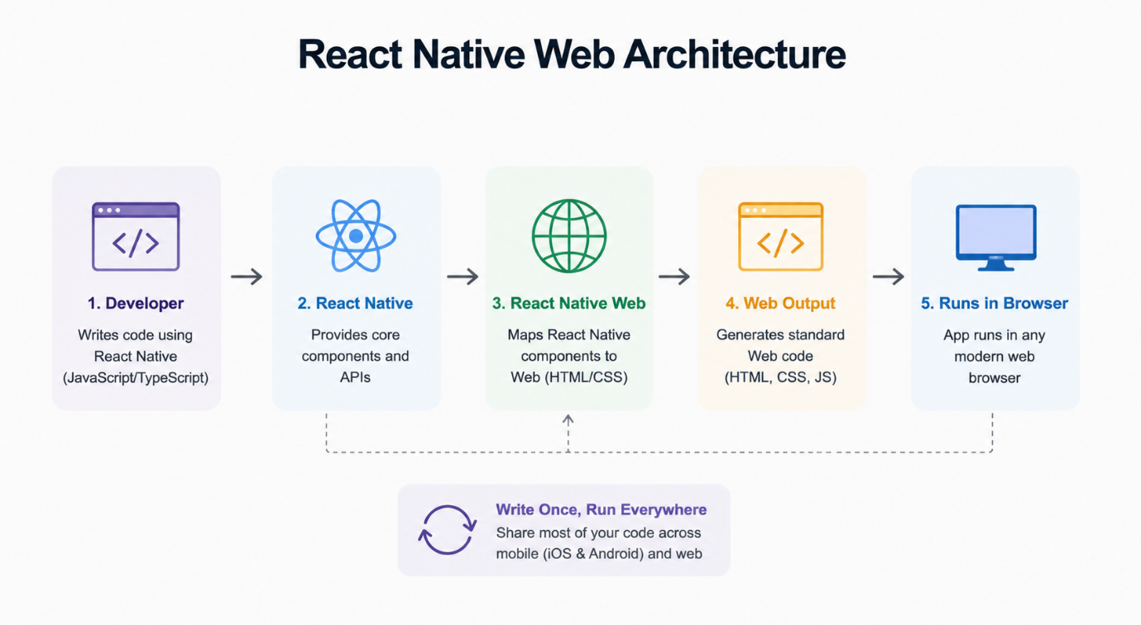

Flow Chart
One React Native Code
↓
Android
↓
iOS
↓
Web Browser

Advantages
Shared Code
Lower Cost
Single Team
Easy Maintenance

How React Native Web Works
Instead of creating separate components for mobile and web, React Native Web maps React Native components to equivalent HTML elements.
React Native Component | Web Equivalent
View | <div>
Text | <span> / <p>
Image | <img>
TextInput | <input>
ScrollView | Scrollable <div>
Pressable | Clickable HTML element

Business Use Case
Admin Panel
Customer App
Website
All using one technology.

6. TypeScript

Definition
TypeScript is a strongly typed programming language developed by Microsoft that builds on JavaScript by adding static type checking.
It helps developers catch errors early, improve code quality, and write more maintainable applications.

📷 TypeScript
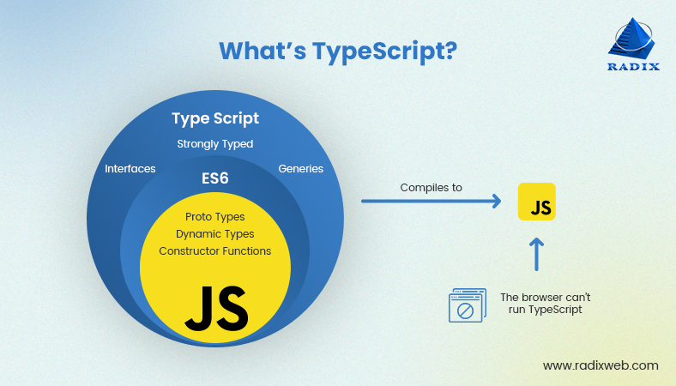

JavaScript vs TypeScript
JavaScript | TypeScript
Dynamic | Static
Runtime Errors | Compile Time Errors
No Types | Types
Data Types
number
string
boolean
array
object
null
enum
void
undefined

Example
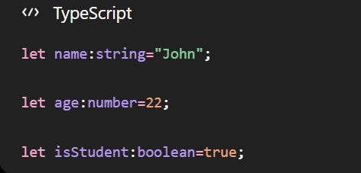

Interface Example
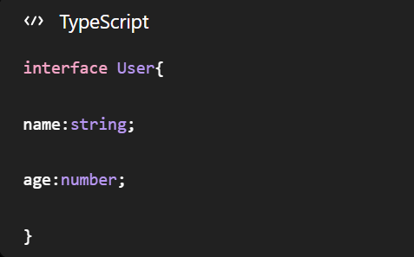
Business Use Case
Large companies like Microsoft, Google, Airbnb, and Shopify use TypeScript because it improves code quality, reduces bugs, and makes teamwork easier on large projects.

